How to run the application:
Prerequisite:
- Java sdk 1.8.0
Steps need to follow:
- Copy the folder “RTS_ATM” in your machine.
- Navigate to the folder RTS_ATM in a console window
- Compile the program using javac *.java
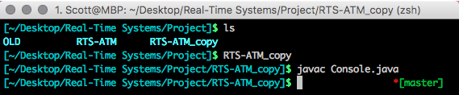
Fig: 1
- Run the program with the java virtual machine by using the command Java Console
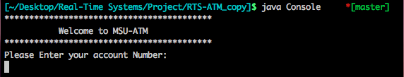
Fig: 2

Logging In:

- Using your debit card number, login to the system:
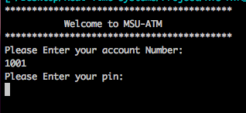
Fig: 3

- Enter your pin to get the main menu:
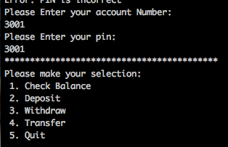
Fig: 4

Check Balance:

- Select “1” to Check Balance:
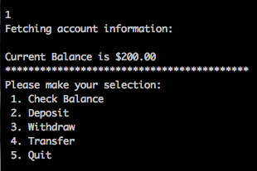
Fig: 5

Deposit:

- While at the main menu, Select 2 to Deposit into your account:
- The system will Query you for the amount to be deposited.
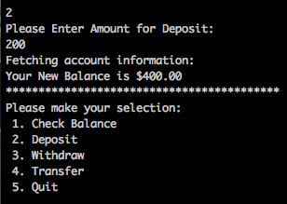
Fig: 6

Withdraw:

- At the main menu, Enter 3 to withdraw cash.
- The system will query you for the amount (if it is over the limit, it will not let you)
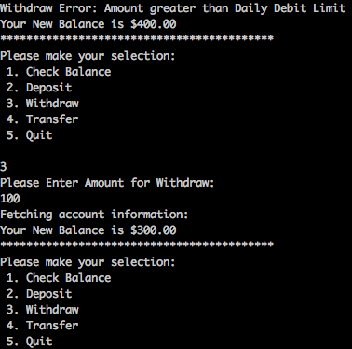
Fig: 7

Transfer:

- To transfer funds to another account, at the main menu enter 4:
- The system will query you for another account number (cannot transfer to source account)
- The system will then query you for an amount to transfer (you cannot transfer more then you have)
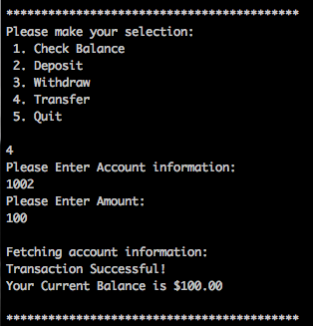
Fig: 8

Quit:

- At the main menu, select 5 to quit and be logged out from the system:
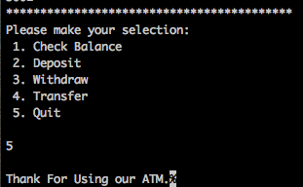
Fig: 9

